In [9]:

**import** numpy **as** np

**import** matplotlib.pyplot **as** plt

**import** seaborn **as** sns

**from** sklearn.datasets **import** fetch_openml

**from** sklearn.model_selection **import** train_test_split

**from** sklearn.naive_bayes **import** GaussianNB

**from** sklearn.metrics **import** accuracy_score, confusion_matrix, classification_rep

**from** sklearn.decomposition **import** PCA

**from** sklearn.manifold **import** TSNE

In [16]:

*# Dataset Loading*

mnist **=** fetch_openml('mnist_784', version**=**1, as_frame**=False**) X, y **=** mnist**.**data, mnist**.**target**.**astype(np**.**int8)

In [22]:

X **=** X **/** 255.0 *# Normalize pixel values # Reduce dimensionality using PCA*

pca **=** PCA(n_components**=**50) *# You can try 30–100 and tune this*

X_pca **=** pca**.**fit_transform(X)

In [31]:

In [32]:

*# Step 5: Evaluation*

print("\nEvaluation Metrics:")

print(f"Accuracy: {accuracy_score(y_test, y_pred) **\*** 100:.2f}%")

print("\nClassification Report:\n", classification_report(y_test, y_pred))

*# Step 3: Model Development (Using GaussianNB as approximation to Bayes' Decisio*

model **=** GaussianNB()

*# Step 4: Training and Testing*

X_train, X_test, y_train, y_test **=** train_test_split(X, y, test_size**=**0.2, random_ model**.**fit(X_train, y_train)

y_pred **=** model**.**predict(X_test)

Evaluation Metrics:

Accuracy: 55.16%

|  |  |  |  |  |
| --- | --- | --- | --- | --- |
| Classification | Report:  precision | recall | f1-score | support |
| 0 | 0.69 | 0.91 | 0.78 | 1343 |
| 1 | 0.81 | 0.95 | 0.88 | 1600 |
| 2 | 0.85 | 0.30 | 0.44 | 1380 |
| 3 | 0.74 | 0.32 | 0.45 | 1433 |
| 4 | 0.83 | 0.13 | 0.23 | 1295 |
| 5 | 0.61 | 0.04 | 0.08 | 1273 |
| 6 | 0.64 | 0.94 | 0.76 | 1396 |
| 7 | 0.91 | 0.28 | 0.42 | 1503 |
| 8 | 0.29 | 0.60 | 0.39 | 1357 |
| 9 | 0.37 | 0.94 | 0.53 | 1420 |
| accuracy |  |  | 0.55 | 14000 |
| macro avg | 0.67 | 0.54 | 0.50 | 14000 |
| weighted avg | 0.68 | 0.55 | 0.51 | 14000 |

In [25]:

conf_mat **=** confusion_matrix(y_test, y_pred) plt**.**figure(figsize**=**(10, 7))

sns**.**heatmap(conf_mat, annot**=True**, fmt**=**'d', cmap**=**'Blues')

plt**.**title("Confusion Matrix") plt**.**xlabel("Predicted")

plt**.**ylabel("True") plt**.**show()

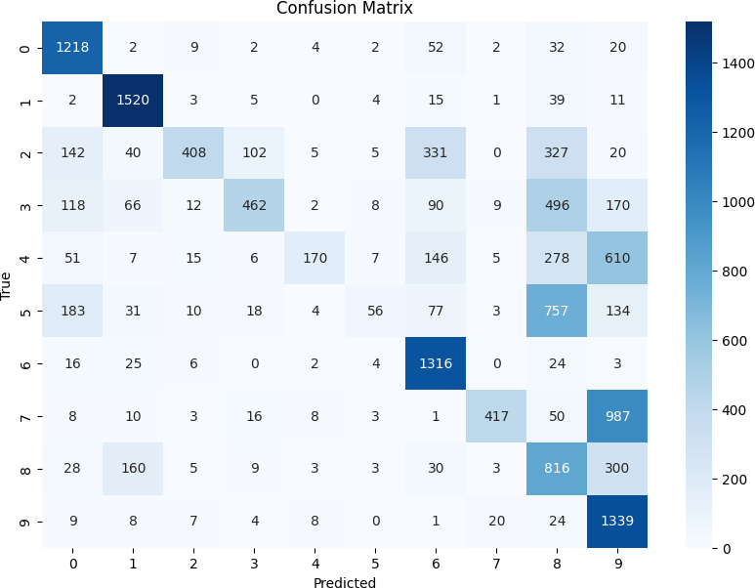

In [29]:

*# Visualization - Correct vs Misclassified*

correct **=** np**.**where(y_pred **==** y_test)[0] incorrect **=** np**.**where(y_pred **!=** y_test)[0]

plt**.**figure(figsize**=**(12, 5))

**for** i, idx **in** enumerate(correct[:5]): plt**.**subplot(2, 5, i **+** 1)

plt**.**imshow(X_test[idx]**.**reshape(28, 28), cmap**=**'gray') plt**.**title(f"True={y_test[idx]}\nPred={y_pred[idx]}") plt**.**axis('off')

**for** i, idx **in** enumerate(incorrect[:5]): plt**.**subplot(2, 5, i **+** 6)

plt**.**imshow(X_test[idx]**.**reshape(28, 28), cmap**=**'gray') plt**.**title(f"True={y_test[idx]}\nPred={y_pred[idx]}") plt**.**axis('off')

plt**.**suptitle("Correctly vs Misclassified Digits") plt**.**tight_layout()

plt**.**show()

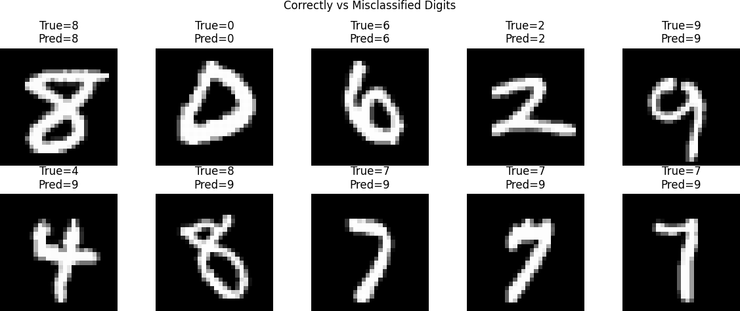

In [27]:

*# Visualize Decision Boundaries with PCA (2D)*

print("Reducing dimensionality for visualization...") pca **=** PCA(n_components**=**2)

X_pca **=** pca**.**fit_transform(X_test)

plt**.**figure(figsize**=**(10, 7))

scatter **=** plt**.**scatter(X_pca[:, 0], X_pca[:, 1], c**=**y_pred, cmap**=**'tab10', alpha**=**0. plt**.**legend(**\***scatter**.**legend_elements(), title**=**"Predicted")

plt**.**title("2D PCA Projection Colored by Predicted Labels") plt**.**xlabel("PCA 1")

plt**.**ylabel("PCA 2") plt**.**grid(**True**)

plt**.**show()

Reducing dimensionality for visualization...

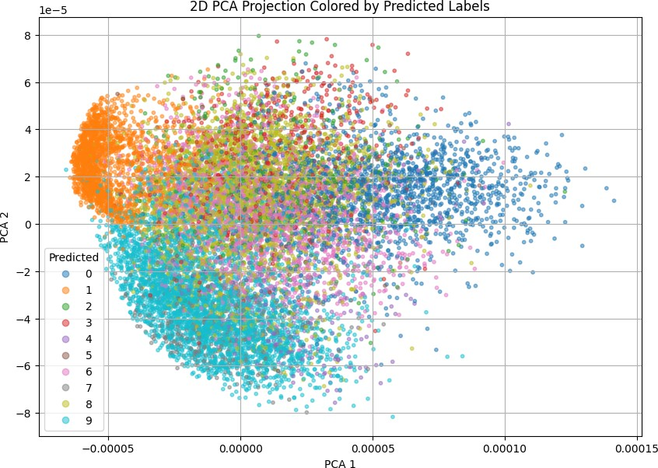

In [ ]: